**PF LAB 04 & 05 TASKS**

**Name: Muhammad Rohaan Roll No: 25K-0026**

**Date: 25th September, 2025 Section: BAI-1A**

**-> TASK #4:**

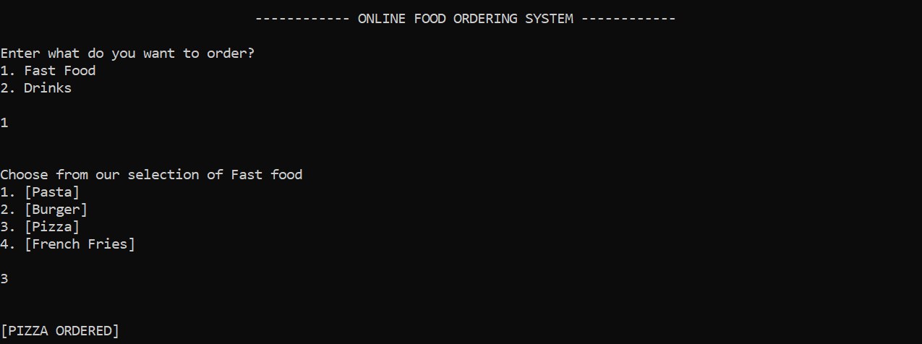

______________________________________________________________________________

**-> TASK #5:**

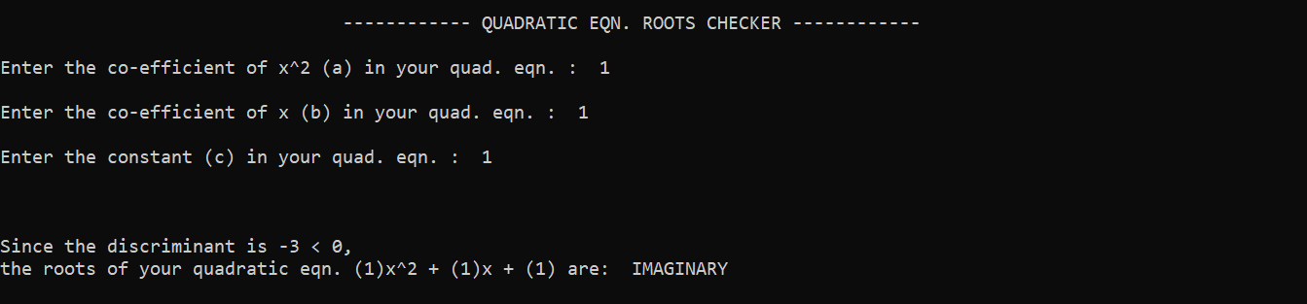

______________________________________________________________________________

**-> TASK #6:**

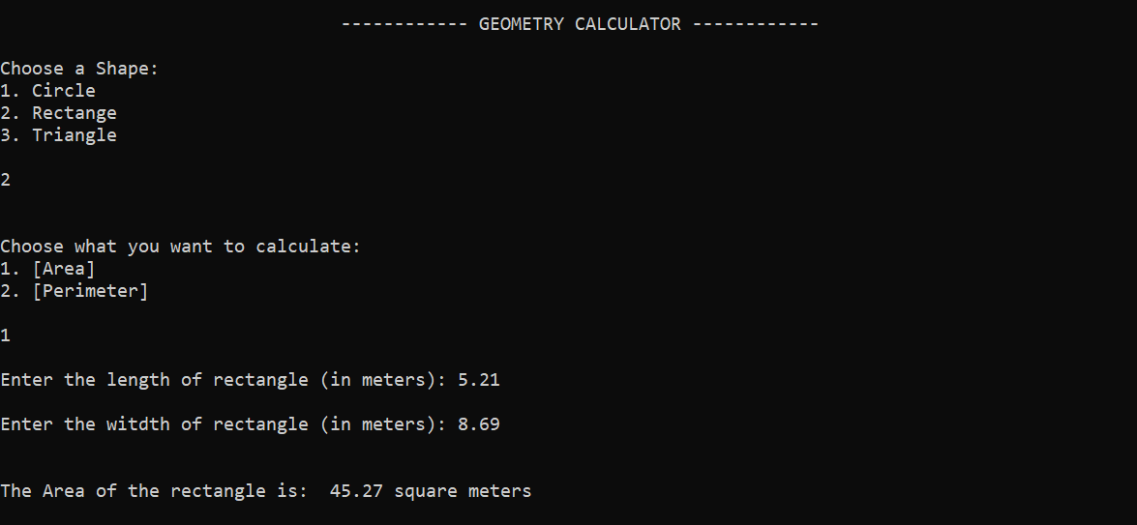

______________________________________________________________________________

**-> TASK #7:**

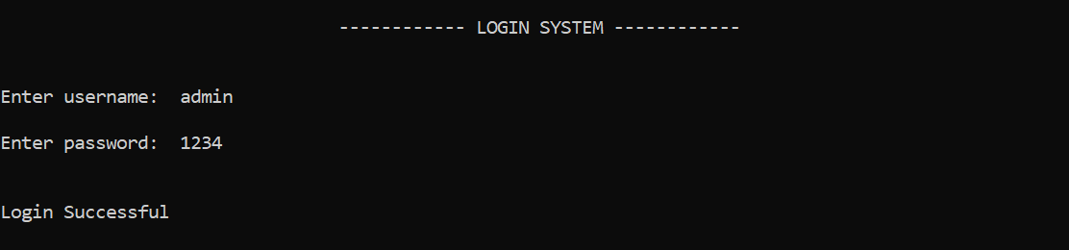

______________________________________________________________________________

**-> TASK #8:**

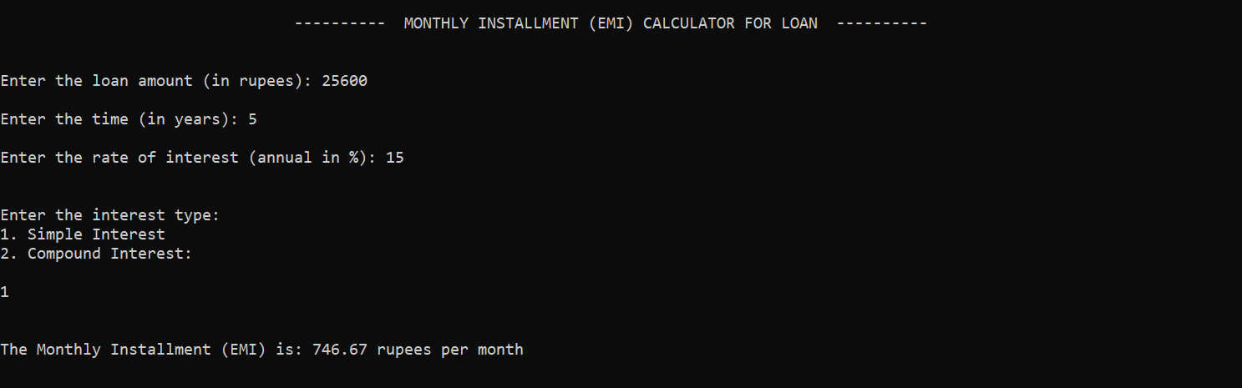

______________________________________________________________________________

**-> TASK #9:**

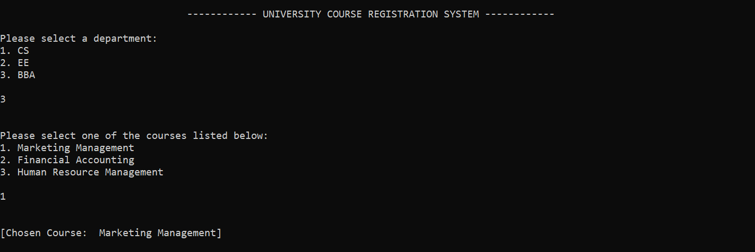

______________________________________________________________________________

**-> TASK #10:**



